JOIN JB TOURS TO……………………………………….
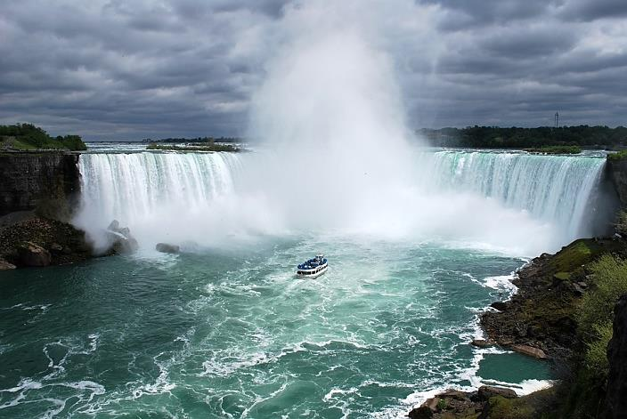
Ontario
and
Buffalo, NY

Niagara Falls

$687

Wednesday - Friday  June 5-7  2019 |  | per person double  Single $824 Triple $639 Quad $618  For credit card payments add $20  Cancellation Insurance available
Your Trip Includes:  - Roundtrip Motorcoach Transportation  - 2-Nights’ hotel accommodations w/luggage handling  - 6 meals  - Oh Canada Eh’ Musical Dinner Show  - Guided tour of Buffalo, NY  - Guided tours of Table Rock/Horseshoe Falls  - Journey Behind the Falls Attraction  - Enjoy a narrated Maid of The Mist cruise  - Visit White Water Walk & Whirlpool Basin Overlook  - Visit the famous 40ft wide Floral Clock  - Visit the NEW – Cave of the Winds  - JB Tours Escort and Gift Certificate Drawing |  | Departures:  6:30 am Fostoria Plaza  7:00 am Findlay Wal-Mart (Tiffin Ave)  7:30 am Tiffin Wal-Mart Lot  8:30 pm Approximate Return time  *** PASSPORT REQUIRED***
A $20 DEPOSIT WILL GUARANTEE YOUR RESERVATION
******FINAL PAYMENT IS DUE 45 DAYS PRIOR TO DEPARTURE *******
In case of cancellation all monies will be refunded, except for any expenses incurred that cannot be recovered.
(NO SHOWS WILL FORFEIT ALL MONIES PAID)
JB Tours  PO Box 150  Fostoria OH 44830 | We Keep the Cost Down & the Excitement up!  419 435-8165 www.jbtours.net |  | 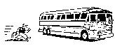

This trip enables travelers to see the Falls from the American and Ontario sides, as well as giving them a tour of some Buffalo city highlights. Remember to have a valid passport for this excursion. If yours in outdated, you can apply for and receive a new one in 3-5 weeks.
Wednesday take in the sites of the beauty and history of Buffalo, including architecture by Frank Lloyd Wright, Victorian neighborhoods, “Mansion Row”, the Waterfront, Gardens, Naval and Military Park, and City Hall including a visit to the 28th floor outdoor observation deck. Head north to check into the hotel to begin the Canadian experience. After freshening up, enjoy the sit-down dinner at “Elements Restaurant” located at Table Rock House overlooking the Horseshoe Falls and Terrapin Point, a truly picturesque dining experience.
Thursday after a breakfast buffet, meet the local Guide who will provide narrative throughout the day. Start with Journey Behind the Falls, followed by lunch at Betty’s Restaurant. Continue on to White Water Walk and Whirlpool Basin, and enjoy the famous 40-ft Floral Clock with seasonal flowers, a perfect photo opportunity. Freshen up at the hotel before departing for the dinner theatre and the All-Canadian Musical, Oh Canada Eh?, which is the longest running musical performing since 1994, giving tribute to over 30 of Canada’s professional recording artists. It promises to be a fun-filled night.

Friday after the breakfast buffet depart for Niagara Falls, USA where there is a visit to the New York State Park, established in 1885, which fulfills a design of natural beauty. A narrated Maid of the Mist boat tour follows, traveling to the base of the American and Horseshoe Falls in the lower Niagara River Gorge. Great views are also seen at Luna Island, Bridal Veil Falls and the American Falls. Continue on to Cave of the Winds and Visitor Center. Take an elevator down to the bottom of the Niagara River Gorge to walk on platforms over rushing water up to the base of Bridal Veil Falls, a spectacular and exciting experience. Enjoy a hot buffet lunch at the Conference Center before departing for home.
So much to do and see, and so little time. JB Tours is dedicated to keeping the cost down and the entertainment up. This trip is a testament to that policy! Be sure to call for further details, 419-435-8165.

