JOIN JB TOURS TO………..
Don Laughlin's
Riverside Resort Hotel & Casino

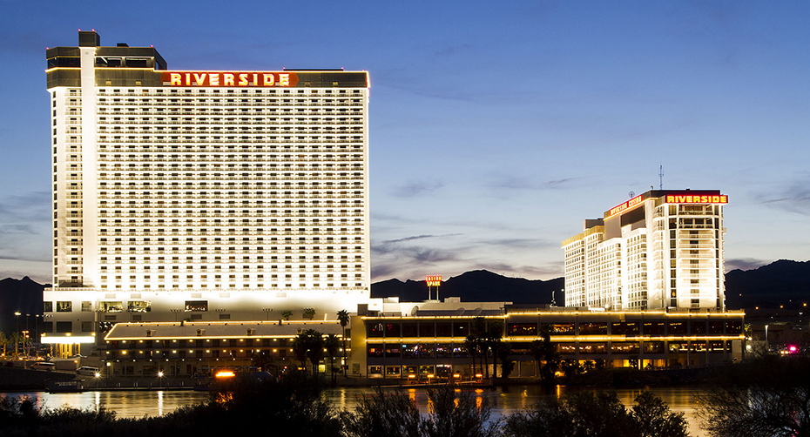
in Laughlin, Nevada
Friday - Monday  2016 |  | Per Person Double Occupancy  $449 Single Occupancy  *Must Be 21 years or Older*
Your Tour Includes:  - Roundtrip transfers to airport  - Roundtrip airfare  - Hotel Lodging at Don Laughlin’s Riverside Resort Hotel & Casino |  | Departures  6:30 am Fostoria Shopping Plaza  7:00 am Tiffin Wal-Mart Lot  7:30 am Findlay Wal-Mart Lot (Tiffin Ave)  6:30 pm Approximate Return Time
A $20 DEPOSIT WILL GUARANTEE YOUR RESERVATION
******FINAL PAYMENT IS DUE 30 DAYS PRIOR TO DEPARTURE *******
In case of cancellation all monies will be refunded, except for any expenses incurred that cannot be recovered
(NO SHOWS WILL FORFEIT ALL MONIES PAID)
JB Tours  PO Box 150  Fostoria OH 44830 | We Keep the Cost Down & the Excitement up!  419 435-8165 800-686-6807  www.jbtours.net |  | 