JOIN JB TOURS TO…………..
Dollywood
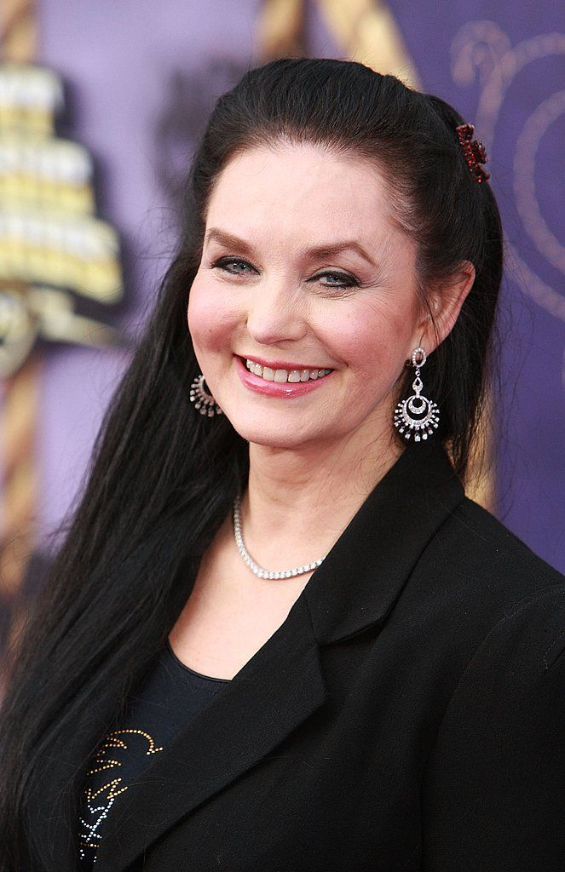
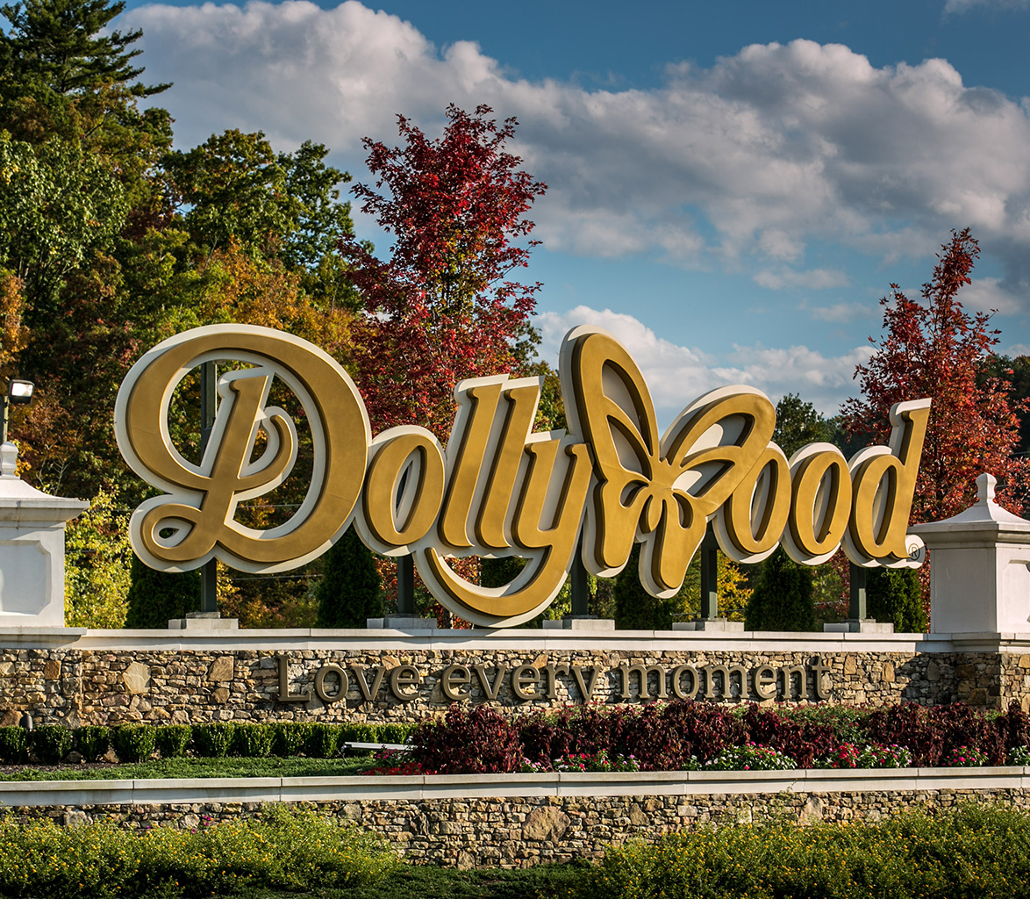
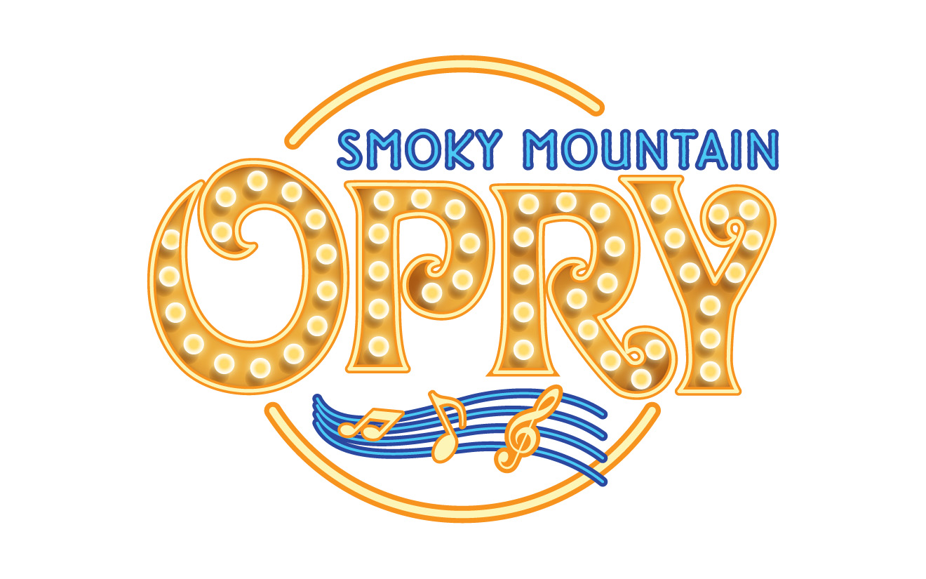
including Crystal Gayle in concert!!

Monday-Thursday  Apr 9-12  2018 |  | $669  Per person double  Single $853 Triple $608 Quad $577  For credit card payment add $23
Your Tour Includes:  - Motorcoach Transportation---Enjoy 6 meals  - Lodging at Summit @ Country Cascades  - The Hatfield and McCoy dinner show  - Magic Beyond Belief starring Darren Romeo  - Explore the Island Pigeon Forge  - Tour the Ole’Smokey Mountains Distillery  - Smokey Mountain Opry  - Experience Dollywood theme park and see Crystal Gayle in concert  - Juggling, music & more at The Comedy Barn  - JB Tours Escort and Gift Certificate Drawing |  | Departure Times  Monday  7:30 am Fostoria Plaza  8:00 am Tiffin Wal-Mart Lot  8:30 am Findlay Wal-Mart Tiffin Ave  ---------- Break en route (on your own)  5:00 pm Check into our hotel  Thursday  5:00 pm Approximate return time
A $20 DEPOSIT WILL GUARANTEE YOUR RESERVATION
******FINAL PAYMENT IS DUE 30 DAYS PRIOR TO DEPARTURE *******
In case of cancellation all monies will be refunded, except for any expenses incurred that cannot be recovered.
(NO SHOWS WILL FORFEIT ALL MONIES PAID)
JB Tours  PO Box 150  Fostoria OH 44830 | We Keep the Cost Down & the Excitement up!  419 435-8165  www.jbtours.net |  | 

