Join Rick and Jill to……….……………………………………….
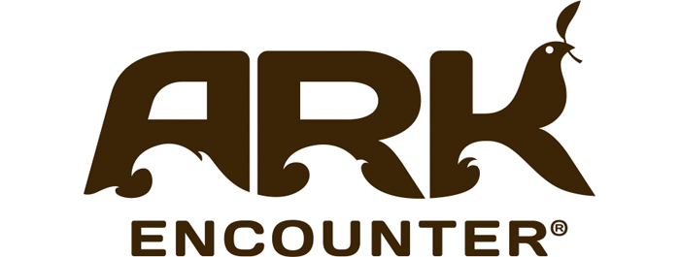
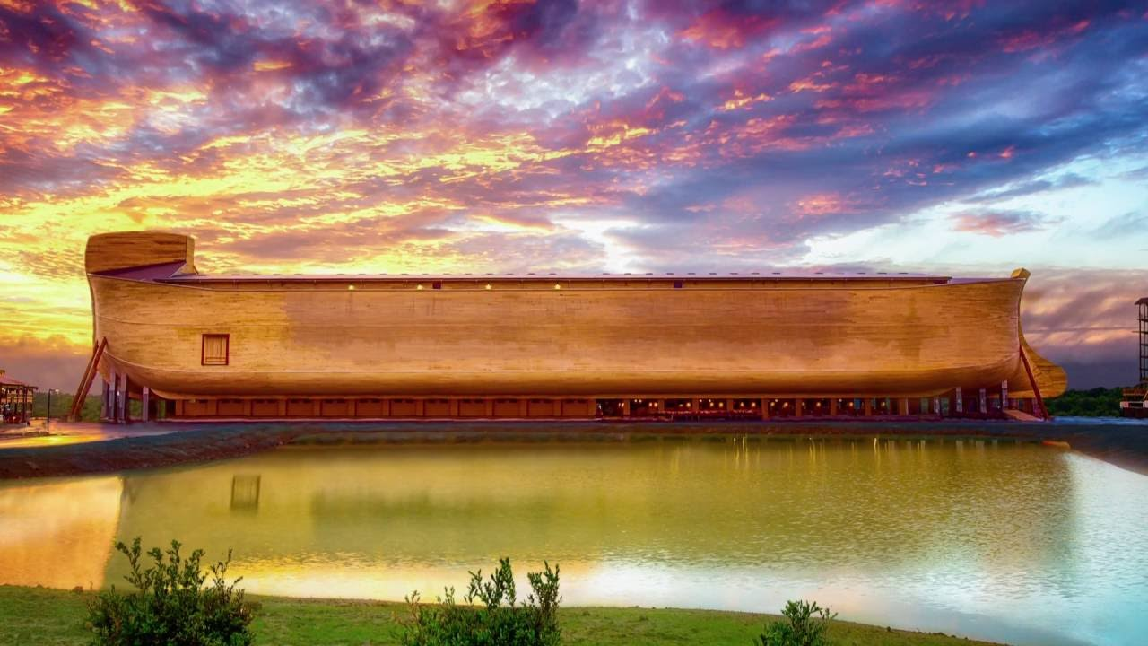
Living Stones Fellowship
and more!
Monday - Tuesday  April 16-17  2018 |  | $314  per person double occupancy  Single $379 Triple $294 Quad $279  cancellation insurance available
Your Tour Includes  - Motorcoach transportation  - 1 night lodging at the Holiday Inn  - 1 Dinner – 1 Breakfast  - Visit the Creation Museum  - Dinner Cruise on the Ohio River  - Toyoto Motor Manufacturing tour  - Visit the ARK ENCOUNTER (Bring your camera!)  - JB Tours escort  - Gift certificate drawing |  | Departures  7:00 am Fostoria Shopping Plaza  7:30 am Findlay Wal-Mart (Tiffin Ave)  10:00 pm Approximate return time
******A $20.00 DEPOSIT WILL GUARANTEE YOUR RESERVATION******
FINAL PAYMENT IS DUE 30 DAYS PRIOR TO DEPARTURE
In case of cancellation all monies will be refunded, except for any expenses incurred that cannot be recovered.
( NO SHOWS WILL FORFEIT ALL MONIES PAID )
JB Tours  PO Box 150  Fostoria OH 44830 | Send Payment to:  Living Stones Fellowship  7751 US 224 W  Findlay, Ohio 45840  (419) 788-9641

