JOIN JB TOURS TO………………………….
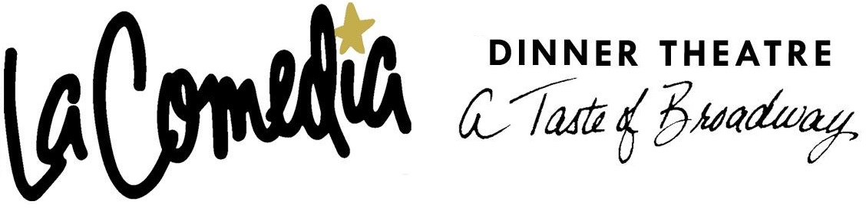
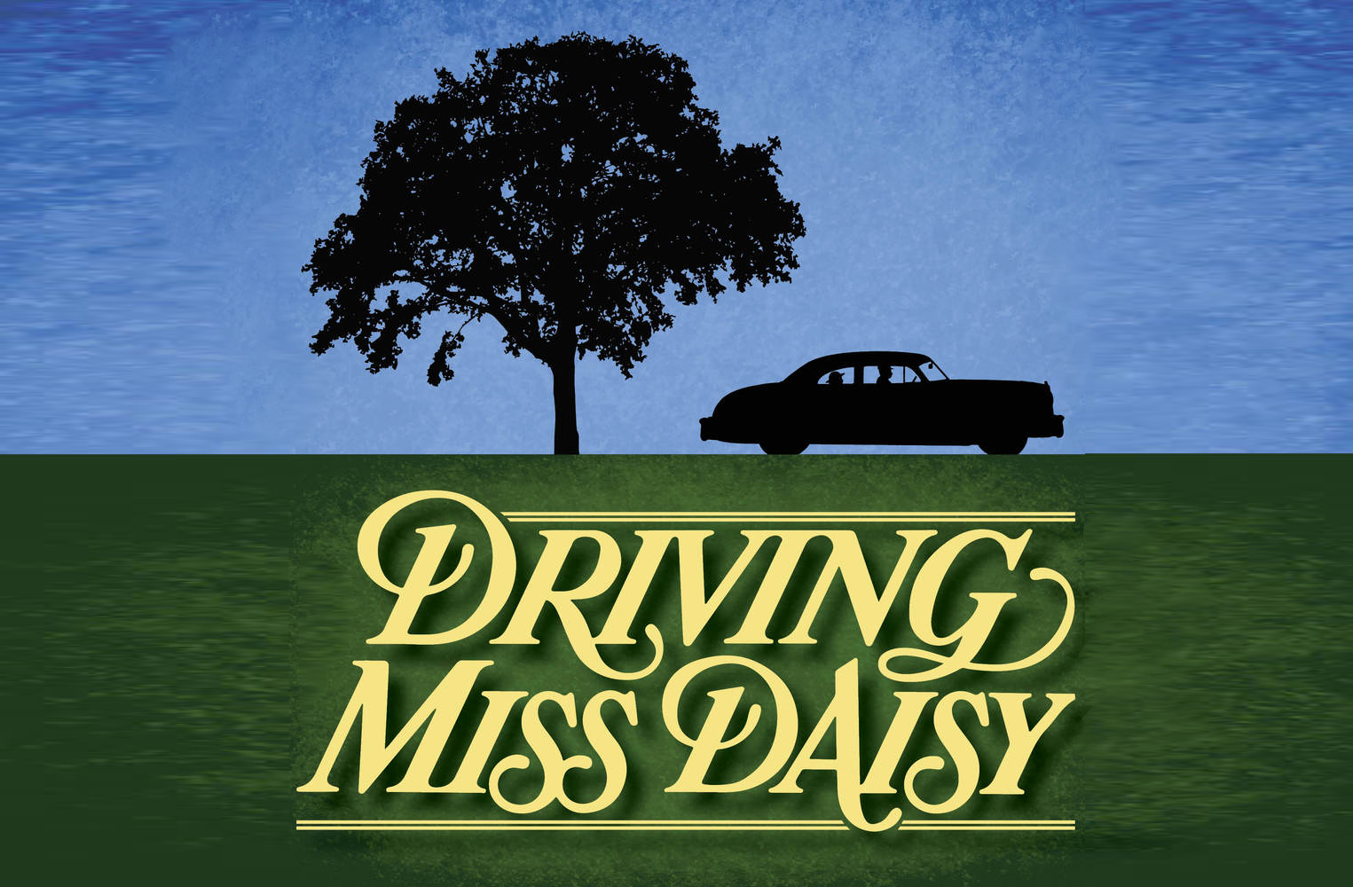
Springboro, Ohio
Thursday  2018 |  | per person  cancellation insurance available
Your Tour Includes:  - Motorcoach Transportation  - Delicious Buffet Lunch  - Reserved Seating  - JB Tours Escort & Gift Certificate Drawing |  | 7:00 am Depart Fostoria Shopping Plaza  7:30 am Depart Tiffin Wal-Mart Lot  8:00 am Depart Findlay Wal-Mart (Tiffin Ave)  ---------- Break en-route  11:15 am Buffet Lunch  12:30 pm Show Time  6:00 pm Approximate Return time
A $10 DEPOSIT WILL GUARANTEE YOUR RESERVATION
******FINAL PAYMENT IS DUE 30 DAYS PRIOR TO DEPARTURE *******
In case of cancellation all monies will be refunded, except for any expenses incurred that cannot be recovered
(NO SHOWS WILL FORFEIT ALL MONIES PAID)
JB Tours  PO Box 150  Fostoria OH 44830 | We Keep the Cost Down & the Excitement up!  419 435-8165 800-686-6807  www.jbtours.net |  | 

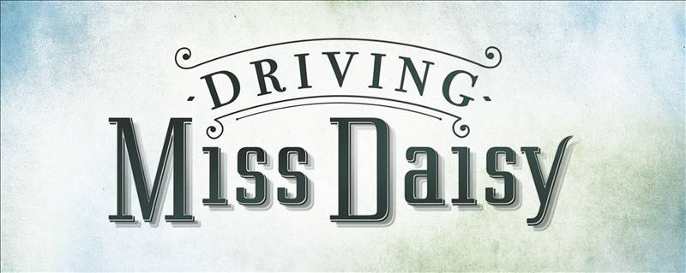

Winner of the 1988 Pulitzer Prize and the Outer Critics Circle Award for Best Off-Broadway Play, Driving Miss Daisy highlights the unlikely relationship between an aging, crotchety white Southern lady, and a proud, soft-spoken black man.

Having recently demolished another car, Daisy Werthan, a rich, sharp-tongued Jewish widow, must rely on the services of a chauffeur.

In a series of absorbing scenes spanning from 1948-1973, the two become close, finding steady comfort and support in each other in a humorous and beautiful journey of friendship.

