JOIN JB TOURS TO………………………….
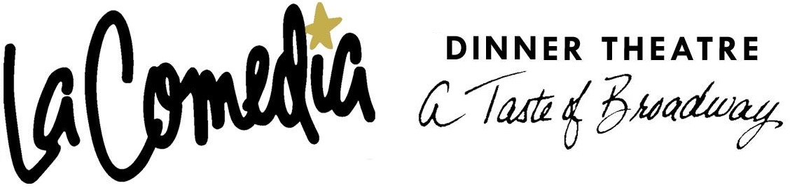
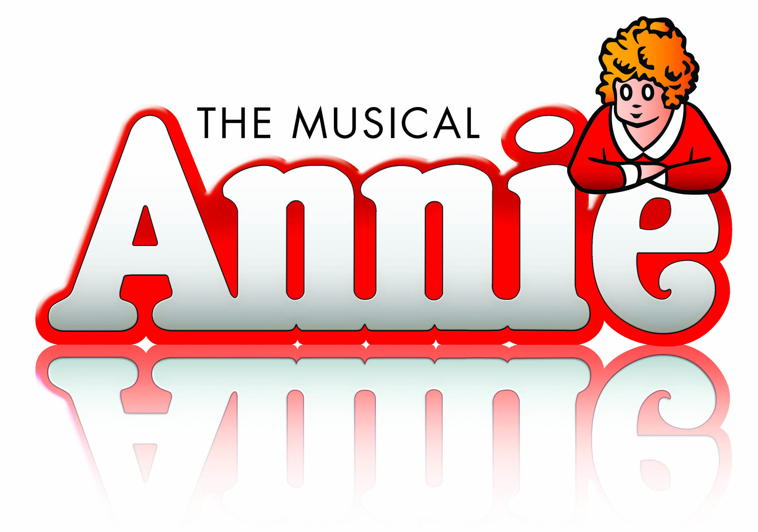
Springboro, Ohio
Thursday  2018 |  | per person  cancellation insurance available
Your Tour Includes:  - Motorcoach Transportation  - Delicious Buffet Lunch  - Reserved Seating  - JB Tours Escort & Gift Certificate Drawing |  | 7:00 am Depart Fostoria Shopping Plaza  7:30 am Depart Tiffin Wal-Mart Lot  8:00 am Depart Findlay Wal-Mart (Tiffin Ave)  ---------- Break en-route  11:15 am Buffet Lunch  12:30 pm Show Time  6:00 pm Approximate Return time
A $10 DEPOSIT WILL GUARANTEE YOUR RESERVATION
******FINAL PAYMENT IS DUE 30 DAYS PRIOR TO DEPARTURE *******
In case of cancellation all monies will be refunded, except for any expenses incurred that cannot be recovered
(NO SHOWS WILL FORFEIT ALL MONIES PAID)
JB Tours  PO Box 150  Fostoria OH 44830 | We Keep the Cost Down & the Excitement up!  419 435-8165 800-686-6807  www.jbtours.net |  | 



Leapin’ lizards, she’s back in town! Annie, America’s favorite cartoon sweetheart, comes to La Comedia in one of the most popular Broadway shows of all time.

It’s a merry comic book world glowing with optimism from its gentle humor, to its carefree dances and tuneful score including “It’s The Hard-Knock Life” and the anthem of hope, “Tomorrow.”

You’ll surely want to adopt Little Orphan Annie for your very own after you see the musical comedy smash hit Annie.

