JOIN JB TOURS TO………. ……………………………………….
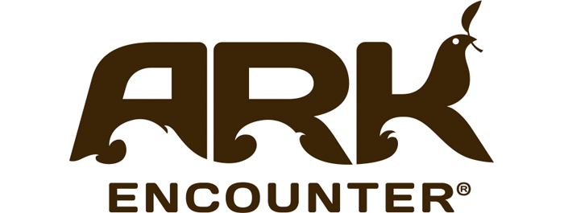
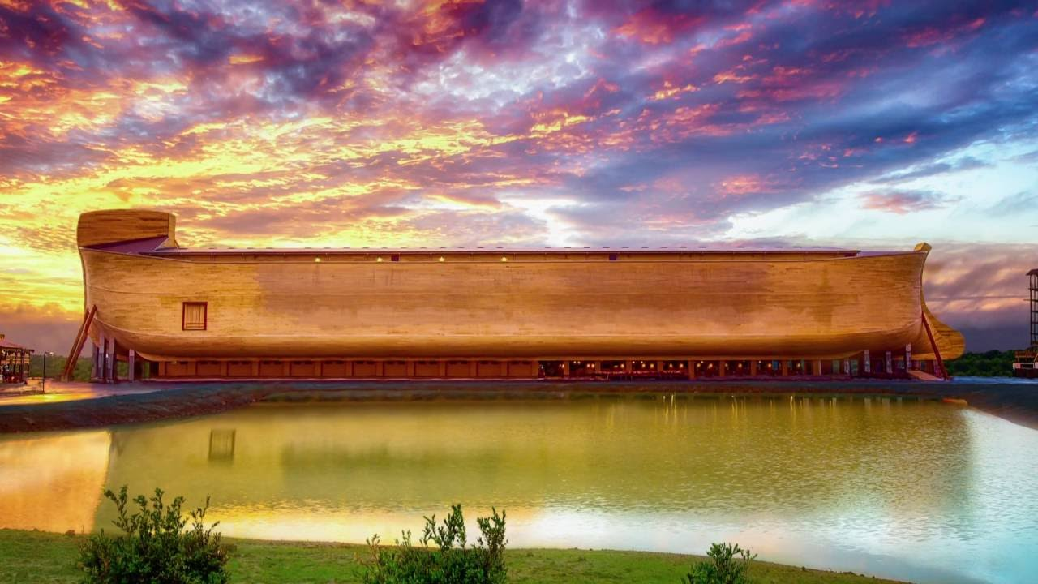
and more!
Tuesday - Wednesday  June 6-7  2017 |  | $369  per person double occupancy  Single $454 Triple $344 Quad $329  cancellation insurance available
Your Tour Includes  - Motorcoach transportation  - 1 night lodging at the Hotel Hampton Inn  - 3 meals  - Visit the ARK ENCOUNTER (Bring your camera!)  - Toyoto Motor Manufacturing tour  - Tour of Old Friends, a retirement facility for pensioned thoroughbreds.  - JB Tours escort  - Gift certificate drawing |  | Departures  7:00 am Fostoria Shopping Plaza  7:30 am Tiffin Wal-Mart Lot  8:00 am Findlay Wal-Mart (Tiffin Ave)  7:00 pm Approximate return time
******A $20.00 DEPOSIT WILL GUARANTEE YOUR RESERVATION******
FINAL PAYMENT IS DUE 30 DAYS PRIOR TO DEPARTURE
In case of cancellation all monies will be refunded, except for any expenses incurred that cannot be recovered.
( NO SHOWS WILL FORFEIT ALL MONIES PAID )
JB Tours  PO Box 150  Fostoria OH 44830 | We Keep the Cost Down & the Excitement up!  419 435-8165 800-686-6807  www.jbtours.net

