JOIN JB TOURS TO……………………………………….
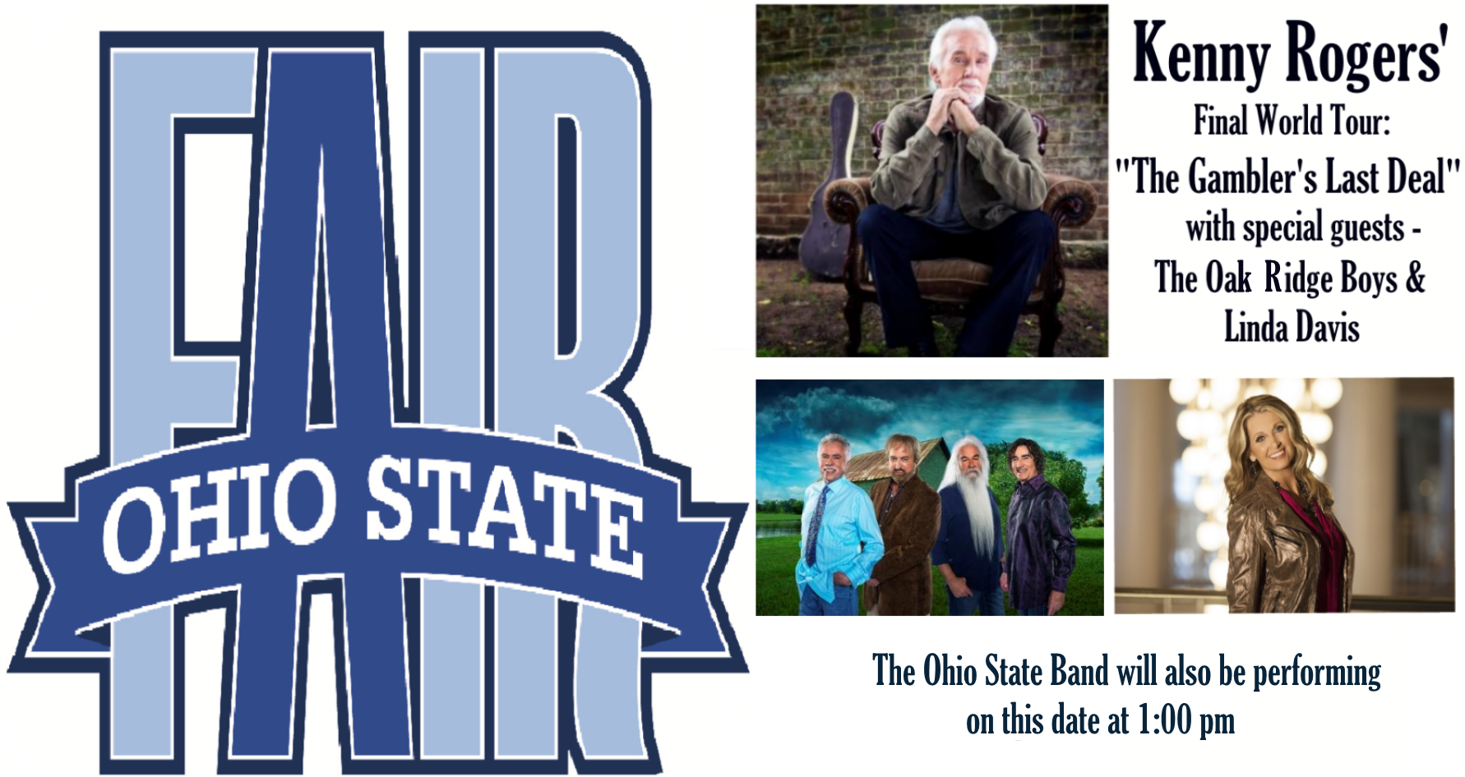
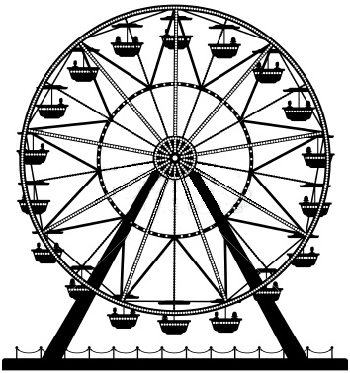  Sunday  July 31  2016 |  | $99 per person  cancellation insurance available
Your Tour Includes:  - Motorcoach transportation  - Admission to the Ohio State Fair  - Ohio State Band  - Reserved seating to the Kenny Rogers Show with Guests- Oak Ridge Boys & Linda Davis  - Gift certificate drawing  - JB tours escort |  | Departures  9:00 am Fostoria Shopping Plaza  9:30 am Findlay Wal-Mart (Tiffin Ave)  10:00 am Tiffin Wal-Mart Lot  ---------- Lunch (on your own)  1:00 pm Ohio State Band  7:30 pm Kenny Rogers and Guests show  11:45 pm Approximate Return Time
A $10 DEPOSIT WILL GUARANTEE YOUR RESERVATION
******FINAL PAYMENT IS DUE 30 DAYS PRIOR TO DEPARTURE *******
In case of cancellation all monies will be refunded, except for any expenses incurred that cannot be recovered
(NO SHOWS WILL FORFEIT ALL MONIES PAID)
JB Tours  PO Box 150  Fostoria OH 44830 | We Keep the Cost Down & the Excitement up!  419 435-8165 800-686-6807  www.jbtours.net |  | 

