JOIN JB TOURS TO ……………………………………….
Tiffin & Fostoria

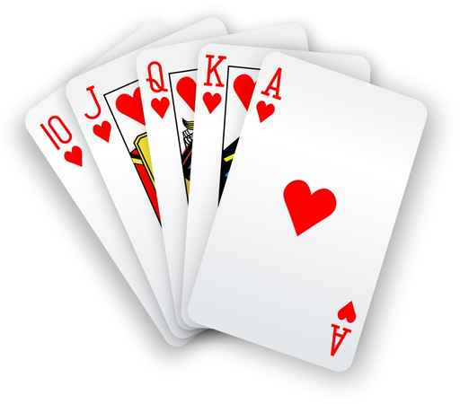

Wednesday  2016 |  | The casino now requires a minimum  of 40 reservations no later than 15 days  prior to the trips departure  You must be 21 years of age
Your Tour Includes:  * Motorcoach Transportation  * $20 Reward Play  * Gift Certificate Drawing  * JB Tours Escort  * Each passenger must present valid photo  Identification upon request of the casino |  | Departures  7:30 am Tiffin Wal-Mart Lot  8:00 am Fostoria Plaza  4:00 pm Depart Casino  6:30 pm Approximate Return Time
******A $10.00 DEPOSIT WILL GUARANTEE YOUR RESERVATION******
FINAL PAYMENT IS DUE 30 DAYS PRIOR TO DEPARTURE
In case of cancellation all monies will be refunded, except for any expenses incurred that cannot be recovered. (NO-SHOWS WILL FORFEIT ALL MONIES PAID.)
JB Tours  PO Box 150  Fostoria OH 44830 | We Keep the Cost Down & the Excitement up!  419 435-8165 800-686-6807  www.jbtours.net |  | 

