JOIN JB TOURS TO……………………………………….
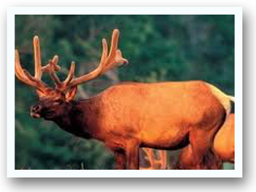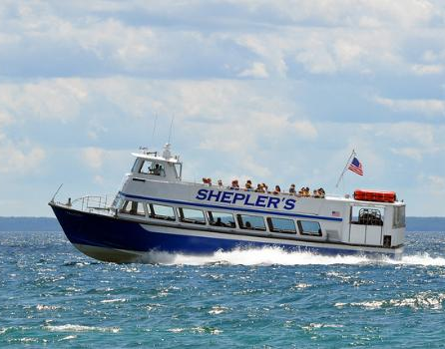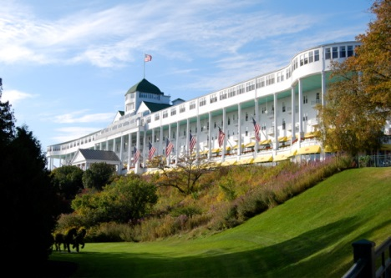
Monday - Wednesday  2016 |  | per person double occupancy  Single $797 Triple $640 Quad $636  cancellation insurance available
Your Trip Includes:  - Roundtrip Motorcoach Transportation  - THUNDER BAY lodging w/ luggage handling  - ELK VIEWING and GOURMET DINNER  - FERRY to MACKINAC ISLAND  - Lodging, Dinner, Breakfast & Lunch at the  GRAND HOTEL on Mackinac Island  - CARRIAGE TOUR of Mackinac Island  - JB Tours Escort and Gift Certificate Drawing |  | Departures:  8:30 am Fostoria Shopping Plaza 9:00 am Tiffin Wal-Mart Lot  9:30 am Findlay Wal-Mart (Tiffin Ave)  10:00 am Bowling Green Meijer Lot  9:30 pm Approximate Return time
A $20 DEPOSIT WILL GUARANTEE YOUR RESERVATION
******FINAL PAYMENT IS DUE 30 DAYS PRIOR TO DEPARTURE *******
In case of cancellation all monies will be refunded, except for any expenses incurred that cannot be recovered.
(NO SHOWS WILL FORFEIT ALL MONIES PAID)
JB Tours  PO Box 150  Fostoria OH 44830 | We Keep the Cost Down & the Excitement up!  419 435-8165 800-686-6807  www.jbtours.net

