JOIN JB TOURS TO……………………………………….

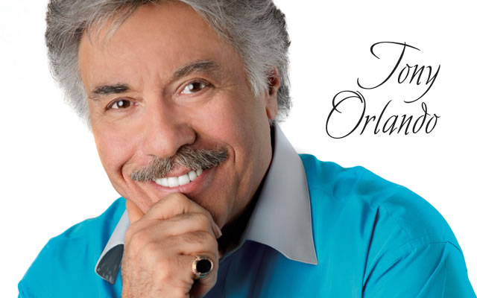


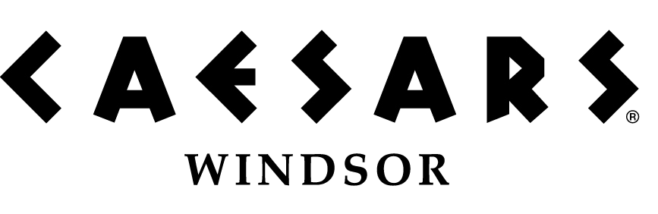

**WINDSOR DOES NOT TAX YOUR WINNINGS!!**
Thursday  Aug 20  2015 |  | $29Per Person  **PASSPORT REQUIRED**  *MUST BE 19 YEARS OLD*  Cancellation Insurance Available
Your Tour Includes:  - Motorcoach Transportation  - Admission to Tony Orlando Show  - JB Tours escort  - Gift certificate drawing |  | Departures  7:30 am Fostoria shopping plaza  8:00 am Tiffin Wal-Mart lot  8:30 am Findlay Wal-Mart (Tiffin Ave.)  6:00pm Approximate return time
A $10 DEPOSIT WILL GUARANTEE YOUR RESERVATION
******Final Payment Is Due 30 Days Prior To Departure*******
In case of cancellation, all monies will be refunded, except for any expenses incurred that cannot be recovered.
(NO-SHOWS WILL FORFEIT ALL MONIES PAID)
JB Tours  PO Box 150  Fostoria OH 44830 | We Keep the Cost Down & the Excitement up!  (419) 435-8165 800-686-6807  www.jbtours.net |  | 

