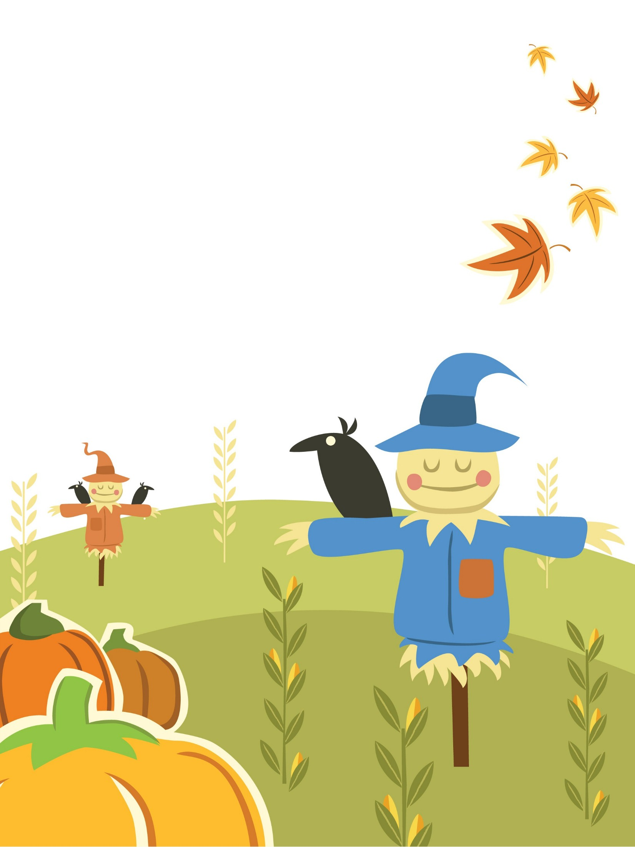
  - Amish
  - Thanksgiving Feast
JB Tours would like you, your family and friends to join us for The Amish Thanksgiving Feast! The meal is prepared by our Amish friends and their families from Holmes and Tuscarawas Counties. RESERVATIONS ARE REQUIRED BY NOV 10TH because of limited seating.
Where: Fostoria Moose, 1230 N. Countyline St. Fostoria (Across from Circle K)
When: Friday, November 21, 2014
Time: Arrive no later than 5:45 pm
Serving Starts Promptly at 6:15 pm
Price: $23 per person

For more information or to make reservations call JB Tours at (419)-435-8165
(Menu on Reverse side)

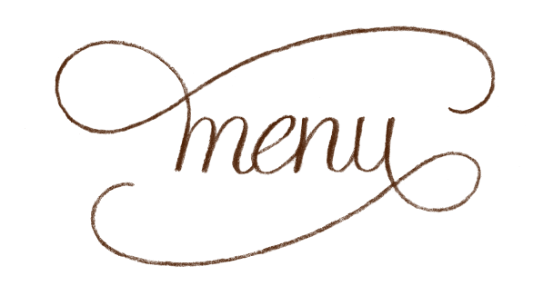

Appetizer
Home Made Bread, Jam and Butter

Main Course
Baked Turkey and Roast Beef

sIDES
Mashed Potatoes & Gravy, Noodles, Dressing, Tossed Salad & Salad Dressing

Dessert
PIES: Pumpkin, Apple, Butterscotch, Pecan, Peach & Peanut Butter Cream

Drinks
Coffee and Iced Tea

